BERT MASON YOUNG AMBASSADOR EUROPEAN AWARD
THESSALONIKI 2021
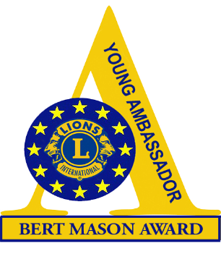
APPLICATION FORM* – to be completed with reference to the Guidance Notes. Please complete in BLACK, either on computer or hand-written.
When complete, one copy should be emailed to your country’s Youth Chairman/Young Ambassador Officer and a second copy to Pompilia Szellner (European Chairman) pompilia.szellner.ps@gmail.com at least 8 weeks prior to Europa Forum.

Candidate’s name

Date of birth/Male/Female
Address

Telephone numbers (land line and mobile) and email address
Name of sponsoring Lions Club and District/Multiple District
Name of Lions’ Contact and email address

PARENT/GUARDIAN’S APPROVAL
I certify that my son/daughter may attend the European Final of the Young Ambassador Award in Thessaloniki and agree that he/she will stay either with a host family or in accommodation with the other candidates.

Signature of parent/guardian: ______________________________________
The candidate should complete and enclose the following:

- A copy of a letter of support for your entry from an organization with whom you are working in the community.
2. Details of your COMMUNITY INVOLVEMENT - information about all your welfare work.
3. Additional information about your hobbies and interests.
4. Information about how you would spend the 2,500-euro bursary (see pages 2 and 3).
5. A passport photograph.
6. A picture that can be used in a PPT presentation.

Please complete the following pages for Use of the Bursary →→→ → → →

USE OF THE BURSARY - This should give details of how you would spend
the amount of the first prize at Europa Forum (2.500 euros).

Please include details of the groups you plan to help and the activities and services that the bursary will help you to provide. The judges of the competition would appreciate as much information as you can give – please continue on additional pages if necessary.

Items to be bought/services provided |  | Estimated Cost – the total should add up to a maximum of 2.500 euros
1.

2.

3.

4.

5.

6.

7.

8.

9.

10.

 | Total Cost

- By signing this document I agree that photographs of me taken during the different activities of the contest will be used in magazines and on social media, for promoting the competition, recruiting new candidates and follow up of candidates.

- By signing this document, I agree that the information provided by me may be used for promoting the competition, recruiting new candidates and follow up of candidates.

Signature of Applicant: ………………………………………………………….

For YOUR SPONSORING LIONS CLUB

The Lions Club of ………………………………. understands that it is their responsibility to authorize the use of the Bursary, should this candidate be a winner at the European Final at Europa Forum and signs their agreement to this condition.

Signed: ……………………………………………………….
Club President

Extra information:

On which account the bursary can be paid:

Name on the account: ……………………………………………
IBAN: ……………………………………………………………….
BIC: ………………………………………………………………….

*Privacy statement
The European committee of the Young Ambassador competition will treat all personal information with the utmost care.
Publication of photographs taken during the different activities will not be used in magazines and on social media without a signed statement from the candidate giving permission.
The information provided by the candidates may only be used for promoting the competition, recruiting new candidates and follow up of candidates if prior permission has been given.
The candidate can ask for available information by contacting the European Committee of the European Young Ambassador. Changes or complete removal of the data can be requested.
The candidate has the right to prohibit the use of information or photographic material for direct marketing purposes.
None of the information will be made available to third parties. All requests can be sent to: wacouni@skynet.be

